**Activities:**

**Gardening**

Jean our resident horticulturist will continue gardening with the students again next term. Spring time is a great time for gardening in our outdoor classroom and it provides a great opportunity for cross-curricular learning.



**Swimming**

Swimming continues to be a great success with the classes in Woodlands and St. Gabriel’s. The children participate well and really enjoy their time in the water.

**We would like to invite parents and staff of Red Hill School to attend and information evening on Cyber Bullying and Internet safety. A broad range of topics will be covered. We will issue an invitation to you on Monday 9th January detailing the content and request that you return the attendance slip the following day.**

**Save the Date**

[Type a quote from the document or the summary of an interesting point. You can position the text box anywhere in the document. Use the Drawing Tools tab to change the formatting of the pull quote text box.]

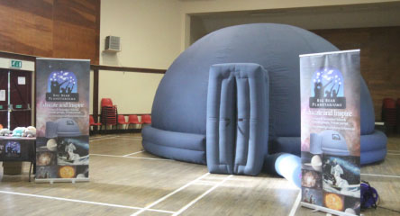

**The Big Bear Planetarium** came on a surprise visit to the school this was kindly sponsored by Fundraising activities on behalf of Kevin Mason. The children found this experience both fun and informative.

**Red Hill School,**

**Patrickswell, Co. Limerick**



**Newsletter**

**December 2016**

**Issue 4**

 ***Santa Flights***

*Our school won flights for Santa in Shannon this year. We held a draw in the school and 10 lucky children with an adult went on the flights on 3rd December.*

***Santa Visits Red Hill School***

A very important person came to visit on December 13th bringing gifts and good wishes to all of our students.

Thank you Santa and thank you Dermott for all the lovely photos.

Christmas concerts and story times have been running over the last week, with our students, parents and staff enjoying the Christmas Festivities. A big thank you and congratulations to all involved.

**Parents Association**

Our hard-working members of the Parents Association have been very busy putting together lovely hampers with the generous donations form you the parents. Tickets are now on sale and the draw will take place on the day of the holidays Thursday 22nd December. Look on our website for the range of hampers to be won. Tickets cost €2 per strip and three strips for €5.

**Dates for your Diary:**

**Christmas Holidays Thursday 22nd December. School re-opens Monday 9th January 2017**

**Mid-Term 23rd and 24th February 2017**

Please note there will bean additional school closure in the 2nd term. Date to be confirmed by the Department of Education and Skills.

School calendar is on ourwebsite.[**www.redhillschool.ie**](http://www.redhillschool.ie)

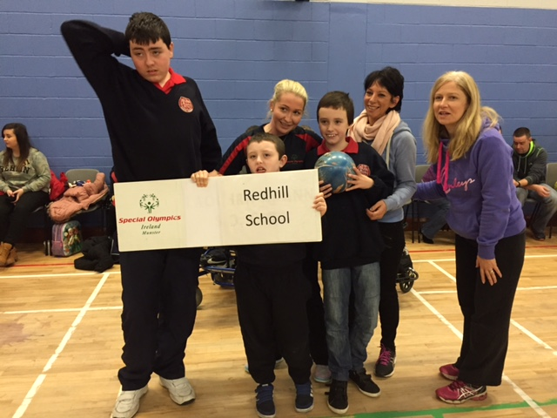

**Special Olympics**

Three of our students competed in the motor activities Special Olympics Competition on Saturday 19th November 2016. Big congratulations to Joshua Logan, Mark Butterfield and Cillian Ryan. A massive thank you to the parents who came on the day and to the staff of Red Hill who volunteered ☺