April News in Elm Class
Our Green Flag committee visited Clareville Water Plant as part of their green flag project.
A fun and interesting time had by all.
They discovered this plant supplies water to our school.
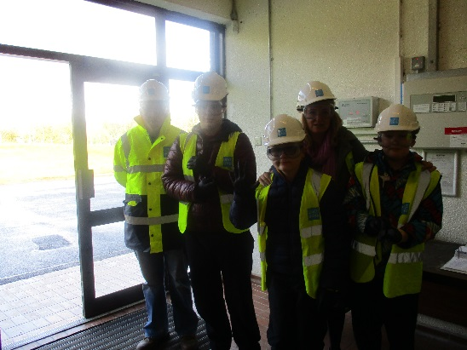
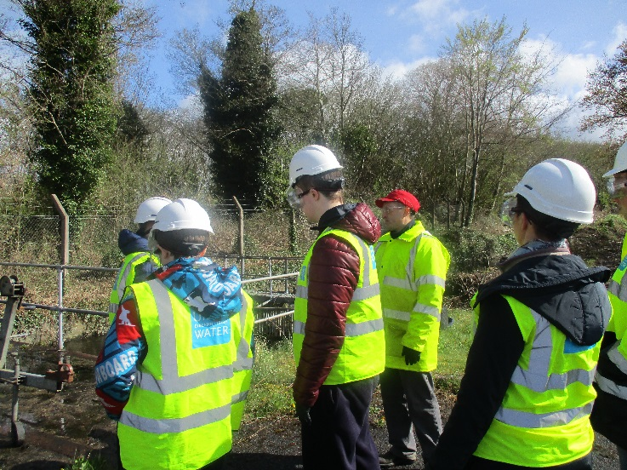

We also did Art with students from the Art College in Limerick City.
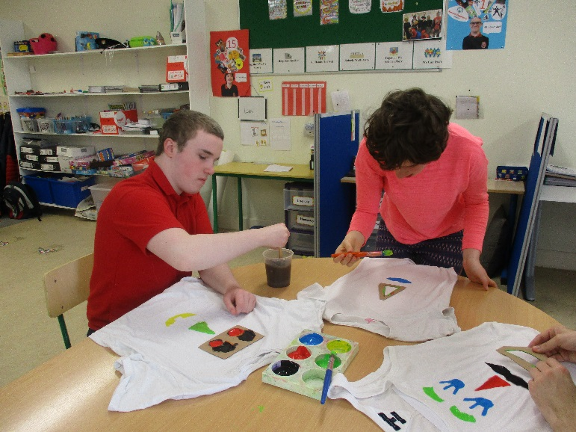
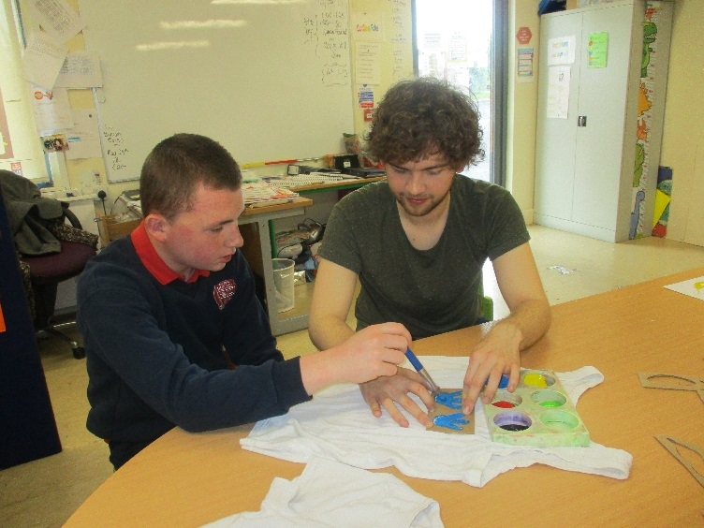
Elm Class

